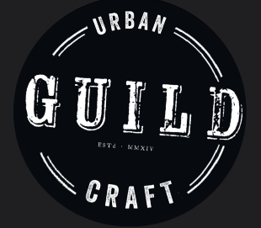
The Guild – Urban Craft & Folk-Art School
Credit Card Authorization Form

Please complete all fields. You may cancel this authorization at any time by contacting us. This authorization will remain in effect until cancelled.

Credit Card Information
Card Type: ☐ MasterCard ☐ VISA ☐ Discover ☐ AMEX
Cardholder Name (as shown on card):
Phone#_______________________ Email________________________
Card Number: CVV:
Expiration Date (mm/yy):
Credit card billing address:

I, , authorize The Guild – Urban Craft & Folk-Art School / Dark Angel Armory & Forge to charge my credit card above for agreed upon purchases, including monthly studio membership, workshop tuition and material fees. I understand that my information will be saved to file for future transactions on my account.

I acknowledge that Open Forges are Tuesday & Thursday evening 6PM-9PM
Safety is our number one concern.
Due to safety concerns, only trained Master-level members have power-hammer privileges. (Unless otherwise advised by management). Power-Hammers are only to be used between 6-8PM.
I will ensure that I (and those around me)
- Follow all safety precautions, studio policies, as well as utilize proper safety equipment.
- Clean up my work area and put tools back when I’m done for the day. (Work surface + Floor).

Please let management know if anything is broken or dysfunctional ASAP so we may repair it.
Please be considerate of others at all times, especially if either of you are working with hot steel, glass or dangerous equipment (welders, grinders, forges, torches etc.).

Member Signature Date

Membership Level:______________________________________

